**Team Budget Planner**

**Output**

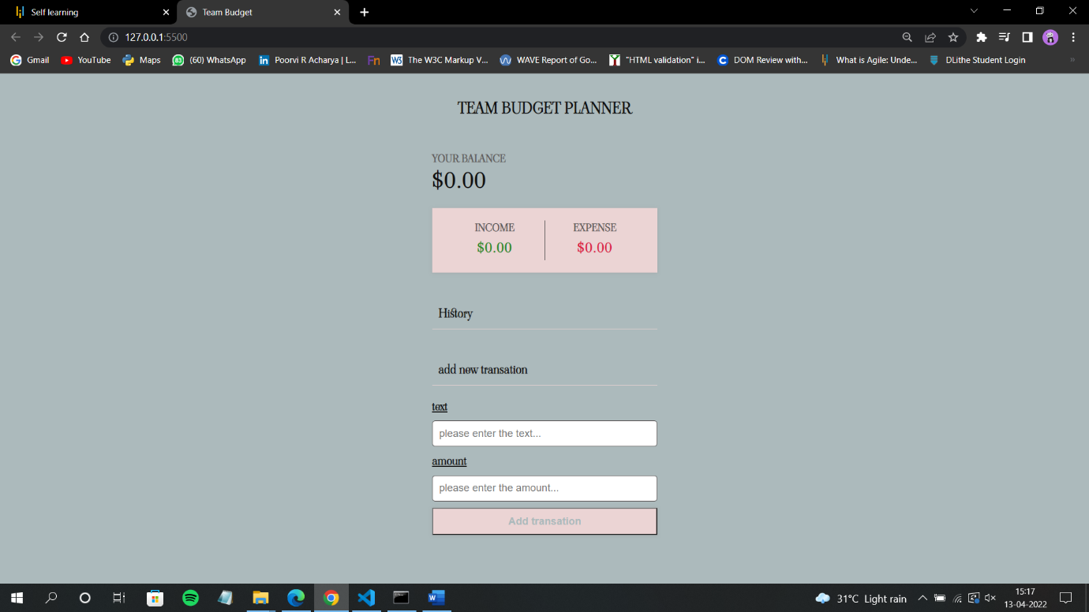**1.Team Budget**

**2.Adding Budget**

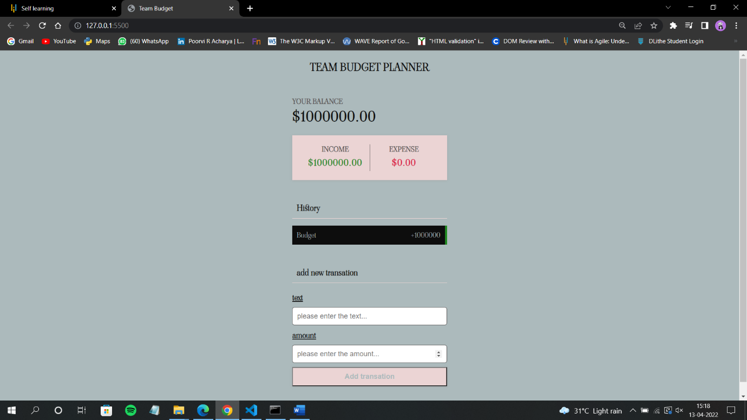

**3.Adding Team1 expenses:**

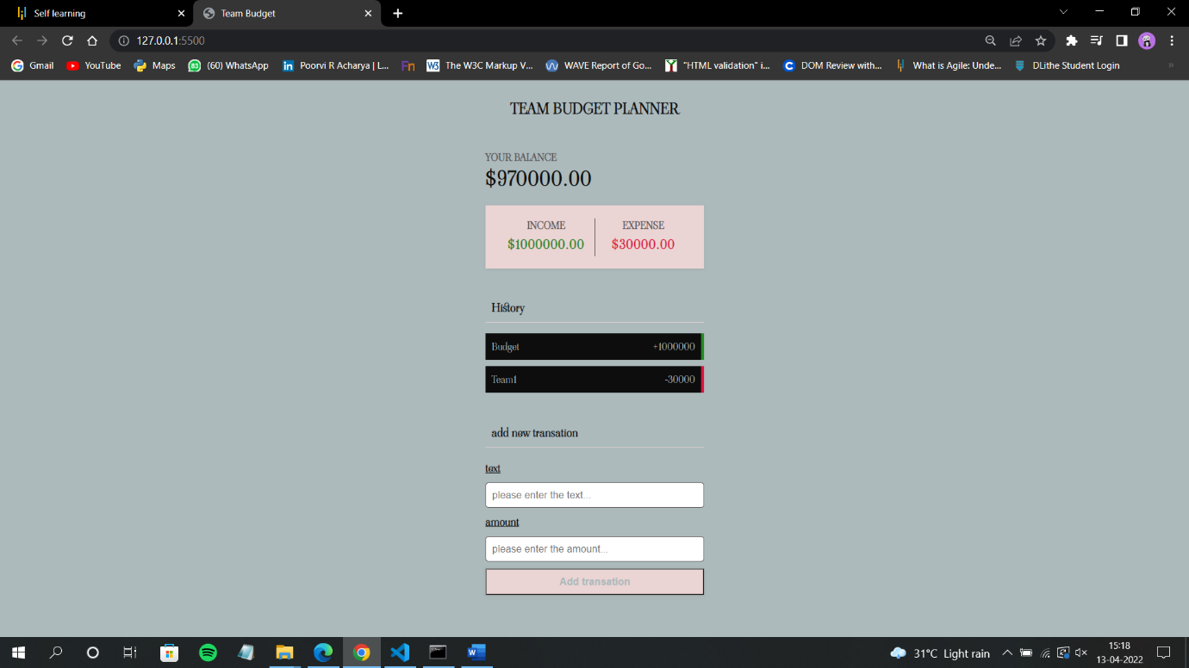

**4.Adding Team2 expenses:**

